This document describes how to use and access Centera using the Global services.

How to install Centera Global Services 3.1?

This tool will allow you to access the Centera from your desktop and configure the centera.
Download the GlobalServices_3_1.exe from \\ott2nas\OTT2NASDATA\OTT_QA\DCTM_Support_Software\Centera_Tools

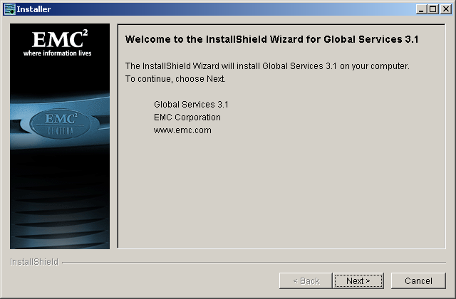

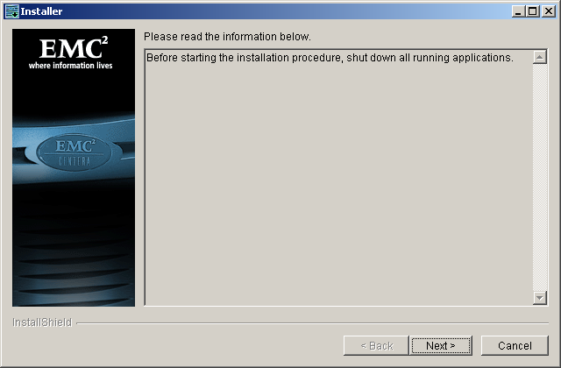

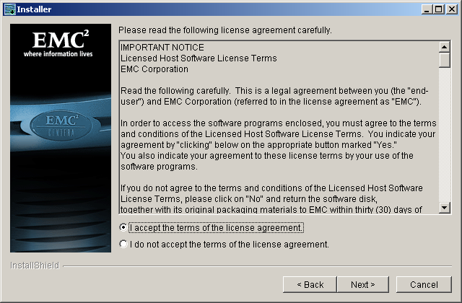

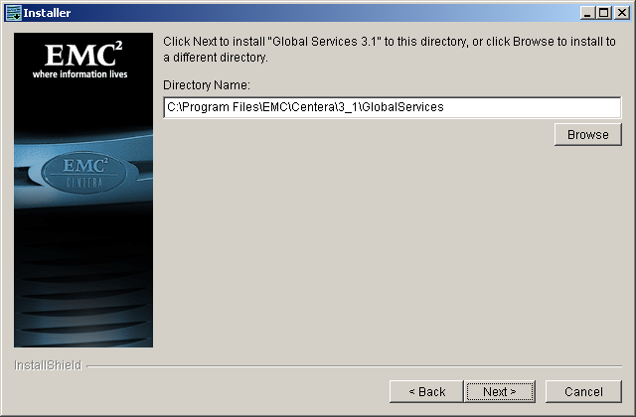
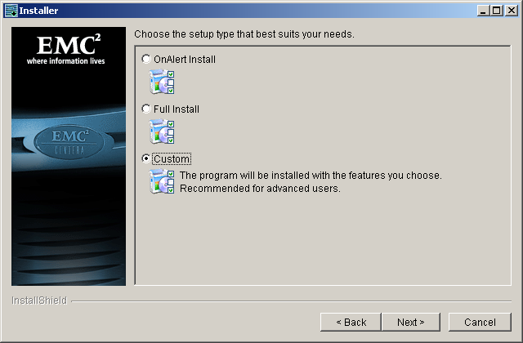

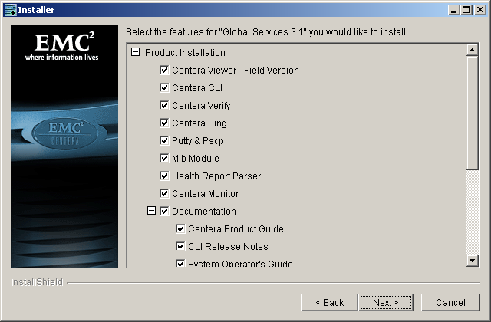

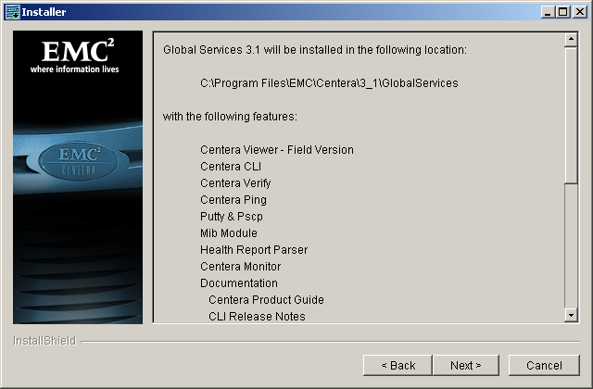

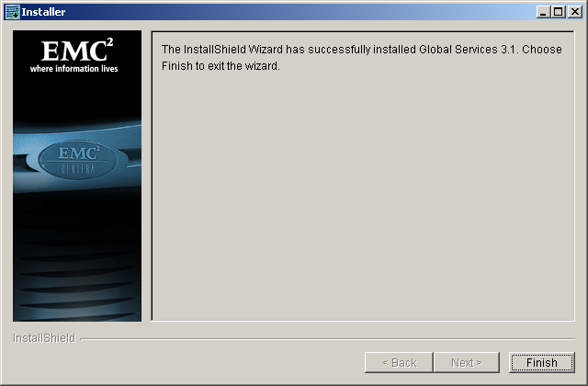

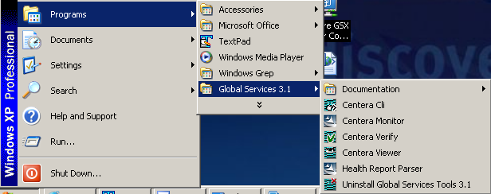

How to verify Centera?

Once you install the global services. You can verify the Centera status, the cluster information and the write read permission. The default IP will display the default profile information. If you need to connect to a specific profile, you need to specify the profile path information with the IP address. See the next section for more information.

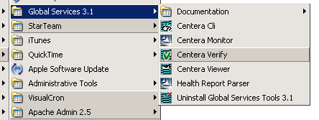

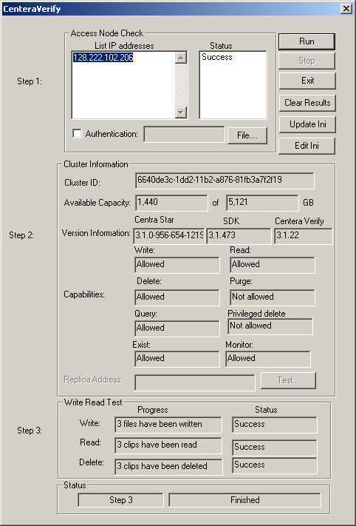

How to verify with a specific profile (pea)?

e.g: <Centera IP>?<file name and the path to the pea file>
128.222.102.206?c:\temp\engprofile.pea

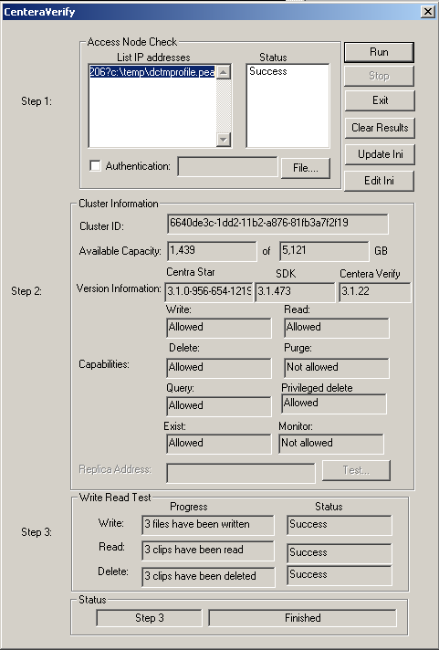
How to use Centera viewer?

Access the Centera viewer application from the global services.

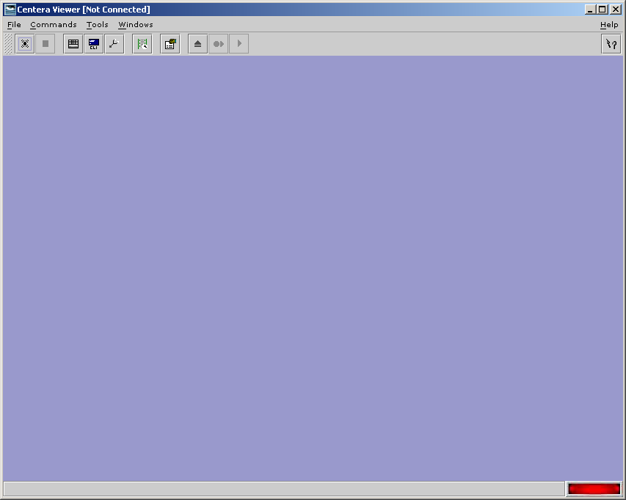

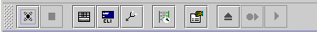

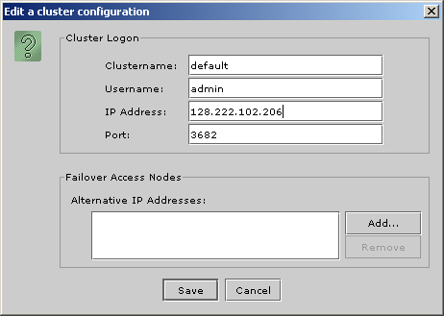

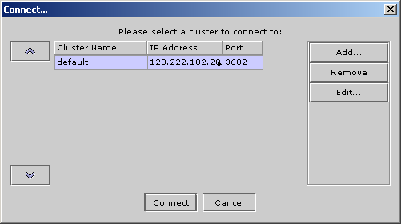

Use the login info admin/centera

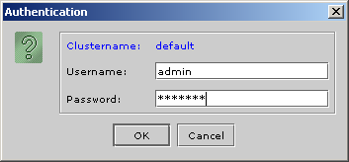
How to use Clip Browser?

Clip browser is used to browse the clips.
- Unzip the ClipBrowser V2[1].1.1.zip. ()
2. Add the Centera user in the users.txt file.
Username: admin
Password: Centera

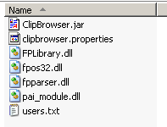
Edit the users.txt to add users.

Start the ClipBrowser.jar

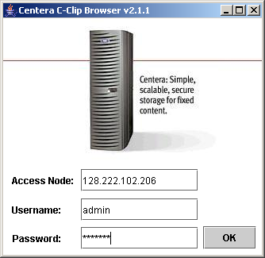

How to create a content addressable storage file store?

Login to the DA and navigate to storage to create a Content addressable storage.

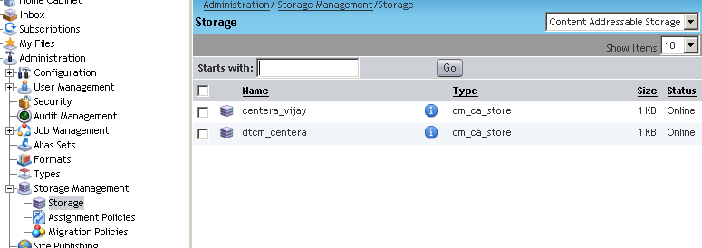
The engprofile.pea is the profile that was created for engineering team. Use this profile to access the engpool. You can download this profile from the following path. \\ott2nas\OTT2NASDATA\OTT_QA\DCTM_Support_Software\Centera_Tools

Enter the pool path 128.222.102.206?c:\temp\engrofile.pea

